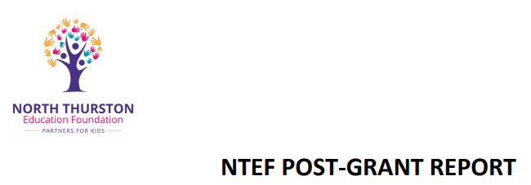
NTEF Grant project name: ___________________________________
School: ____________________________________________________
Grant received: [20__-__ school year]
Completion date: [input xx/xx/xx] Even if not completed, funds must be spent by June, 1 of the school year received, and a report of what has been done by March 30th of the school year given.
Post Grant Report due date: Within 30 days of completion or by March 30 of the school year given)

Contact information:
Name of person grant was awarded to: ____________________________________________________
Phone number: ____________________ Email: _______________________________________

Report
- Did you spend the entire grant amount? Yes _____ No ______ Unused funds will be returned to NTEF.

- Tell us how the grant money helped you achieve your goals.

- Restate expected outcome.

- Did you achieve your anticipated goals?

- List some highlights and areas of missed opportunities.

- Please share a story about how the grant money helped a group or individual learn or grow. (Photos are appreciated! Send to: Deanna@ntef.org )

- Please include any data you may have collected in monitoring the progress and outcome of your project, i.e. pre and post graphs and student outcome.

- Is this a project you feel that other educators and student would benefit from? Why or why not?

- How could we improve the foundation grant process?

SUBMIT YOUR COMPLETED FORM WITHIN 30 DAYS OF PROJECT COMPLETION OR BY MARCH 30 OF SCHOOL YEAR RECIEVED TO:
Deanna East, Executive Director, Deanna@NTEF.org . Questions? Call 360-628-3281

